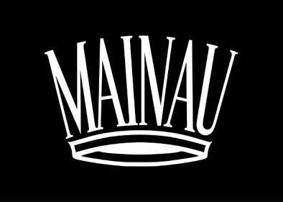

(Island x Palm Tree)² - A Numbers Game and a Plus for Colours

Under the 2017 motto (Island x Palm Tree)², visitors to the Flower Island Mainau will discover the close relationship between nature and mathematics in many aspects. The stage for this numbers game is set with shimmering Lake Constance and the Alps in the background – when fragrant blossoms burst onto the scene, a delightful plus of colours emerges.

Mainau’s 2017 flower theme offers a fresh perspective and new way of looking at nature. Throughout the park and its impressive gardens, the theme reveals exciting mathematical correlations and highlights precise geometric forms like spheres, hexagons or rectangular prisms that can be found in nature. It’s a numbers game played by the plant world. Information stations along the way describe the ‘record holders’ in the plant kingdom, as well as the most important mathematicians and their theories with regard to Mother Nature.

There are many highlights in 2017, among them the blossoming of thousands of tulips, hundreds of rhododendrons and two large sweet-smelling rose gardens. Endless perennials enrich the scenery as well as colorful dahlias in late summer. A 150 year old arboretum with mighty sequoia trees lies at heart of Mainau park. Palm trees and citrus plants bring a Mediterranean flair to the island in summer. Children love the Mainau Kinderland with its many games, adventures and animal farm. The Butterfly House, one of the largest in Germany, is an exotic oasis of 120 varieties of butterflies fluttering around and feeding on tropical nectars. Mainau Castle and the Castle Church St. Marien built by the Teutonic Knights from 1732 to 1746 are architectural jewels of the Baroque period.

Mainau can be explored even further during events like the Count’s Island Festival, May 25-28 and the Count’s Castle Festival, September 29-October 3. Exhibits in the castle as well as open air concerts complete summer on the flower island.

The island’s gastronomy with its cafés and restaurants located throughout the park is the home of many culinary delights. Special themed menus mirror the 2017 motto of “A Numbers Game and a Plus for Colours”. One example is the colour plus menu series: seasonally changing monochromatic dishes where Mainau chefs prepare a menu and drink using only one color.

Technically speaking, the new user-friendly Mainau App “Proxipedia” will be realized during the year 2017. Loaded with background history and information, the App is a playful way for visitors to access customized information about Mainau. Working closely with German Telekom, Mainau is now one of the first tourist locations in Germany to get three Small Cells allowing T-Mobile customers as well as foreign guests (via roaming) to make mobile phone calls at the latest technical level - a low EMF option in keeping with Mainau Island’s commitment to sustainable practices.

Additional information: www.mainau.de

Further information:
Mainau GmbH, Tel.: +49 7531/303-138, Fax: +49 7531/303-160,
E-Mail: presse@mainau.de

