Friedrichshafen: The Year of the Pioneers – 25th Anniversary of the Zeppelin Museum
“You only have to want it and to believe in it, then you will succeed,” said Ferdinand Graf von Zeppelin, who secured the imperial patent for a steerable air train in 1898. He later hired Claude Dornier, founder of the Dornierwerke, as an aircraft designer. Even today, it is not only these two pioneers – who left their mark on the city – that are a source of inspiration. You will find their traces throughout the city, on themed tours and explorations of the city, in the museums and in the Zeppelin Hangar.
Zeppelin NT – the most beautiful way to fly
The engines whirr quietly. Gently the white giant rises up and glides elegantly through the sea of air. The Zeppelin NT lays the world at its passengers’ feet – with impressive views. Shortly after take-off, you reach the flying altitude of approximately 300 metres. On board, guests are free to move around and look over the captain’s shoulder. Every seat offers a breathtaking view thanks to large panoramic windows. Experience the weightless Zeppelin feeling and simply lean back – in the comfortable leather seats, with its unobstructed view of the horizon, the hectic pace of everyday life “flies away”. The Zeppelin NT explores the skies via 12 different routes. Take-off and landing take place at the Zeppelin hangar in Friedrichshafen. If you would like to take a look behind the scenes, you can gain fascinating insights into the world of modern airship construction during a tour of the shipyard – including exciting technology you can touch.
Zeppelin NT – proud legacy of a great visionary and technological benchmark of a new airship generation
On 2 July 1900, the first rigid airship from the airship pioneer Ferdinand Graf von Zeppelin took off over Lake Constance near Friedrichshafen. Altogether, 119 air giants were built during the great airship era from 1900 to 1938. In Friedrichshafen, belief in the rebirth of the Zeppelins was never completely lost. With the founding of Zeppelin Luftschifftechnik GmbH & Co. KG in 1993, reliable empirical values from the glorious days of airships were combined with current, high-tech methods with the vision of enabling comfortable airship flights and flying special missions that are not possible for other aircraft.
The Zeppelin New Technology was born. On 18 September 1997, the Zeppelin NT took off on its maiden flight over Friedrichshafen. The Zeppelin myth had returned.
Deutsche Zeppelin-Reederei GmbH
Andrea Fischer
Head of Marketing, PR & Sales
Messestraße 132, 88046 Friedrichshafen, Germany
Telephone: +49 (0)7541 5900 547
presse@zeppelin-nt.de, www.zeppelinflug.de

Discover the Zeppelin Museum as a place of innovation
Zeppelins, the world-famous airship giants from Lake Constance, have been thrilling people since 2 July 1900. On this day, LZ 1 rose for the first time in Manzeller Bucht near Friedrichshafen. For 25 years, the Zeppelin Museum in Friedrichshafen has been the best place in the world for inquisitive minds of all ages to learn all about the past, present and future of airships. It is not only about innovation and daring journeys, but also about the historical background and the people who conceived and built the airships and then flew them across the oceans.

Are you interested in the iconic Zeppelin and the pioneers of airship travel?
How did Graf Zeppelin manage to build an airship almost four times the size of an Airbus, yet lighter than air? Do you want to trace the myth of the Lakehurst disaster?
The more than 1,500 original exhibits, historical audio, video recordings and photographs from the Zeppelin Museum’s multimedia collection, which attract more than 250,000 international visitors every year, tell the story of airship travel in vivid detail. In the exhibition, for example, flying according to the “lighter than air” principle is clearly explained and can be experienced at experiment stations. The successful history of the Zeppelin Group and its pioneers shows how technical innovations were created and why the cult of the Zeppelin has been celebrated for over a century.
The highlight is the partial reconstruction of the LZ 129 Hindenburg. Via the gangway, visitors climb into the passenger areas of the LZ 129, which have been recreated in their original size according to historical plans, and can experience at first hand how it felt to be a passenger on this innovative luxury liner of the skies.
The Zeppelin Museum in the Bauhaus building at the harbour railway station is not only a centre of excellence for the history of zeppelins, but also has a remarkable art collection that brings together the great masters of southern Germany from the Middle Ages to modern times. A special focus is the works of artists who withdrew to Lake Constance during the “Inner Emigration” during the Third Reich, such as Otto Dix, Max Ackermann and Willi Baumeister. Through its innovative temporary exhibitions in particular, the Friedrichshafen museum spans an arc to contemporary art.
25 years of the Zeppelin Museum! SAVE THE DATE: There will be a birthday celebration on 2 July 2021. How, where and what is still a secret.
You can find guided tours and events updated daily at www.zeppelin-museum.de.
Zeppelin Museum Press
Simone Lipski
E: lipski@zeppelin-museum.de
Telephone: +49 (0)7541 3801 21
lipski@zeppelin-museum.de, www.zeppelin-museum.de

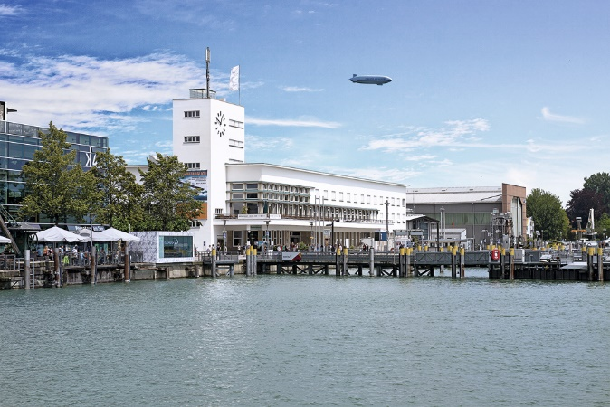
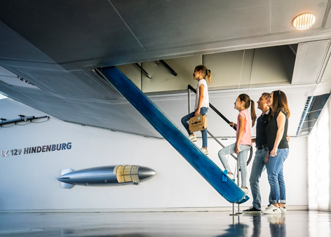
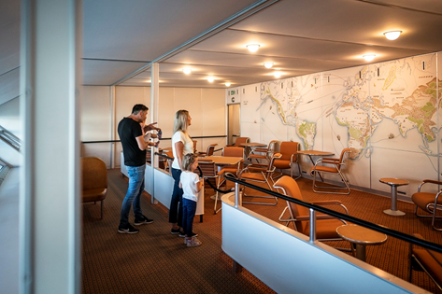
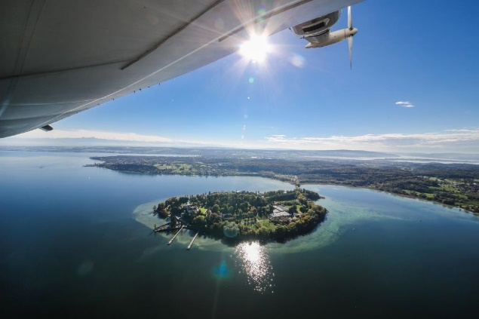
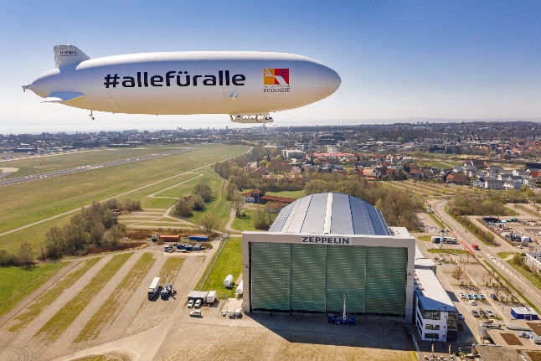
Lakeside aspect of the museum buildings © i-d Büro
Zeppelin in flight © Michael-Haefner
Reconstruction © Zeppelin Museum Foto Denger
Gangway © Zeppelin Museum Foto Denger
Zeppelin hangar © Michael-Haefner

